**Leaving Cert Physics Long Questions 2018 - 2002**

1. ***Geometrical Optics***

***Please remember to photocopy 4 pages onto one sheet by going A3→A4 and using back to back on the photocopier***

Contents

Mirrors 2

Refraction 3

Optical Fibres 5

Lenses 8

Solutions to higher level questions 10

# Mirrors

**2017 Question 7 [Ordinary Level]**

A ray of light can undergo both reflection and refraction.

1. 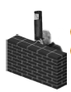What is meant by reflection of light?
2. State the laws of reflection.
3. The periscope, like the one in the diagram, is an application of the reflection of light that allows a person to see over objects.  
   Draw a diagram to show how a periscope works.

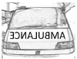

1. The diagram shows the word AMBULANCE written so that a driver can read it correctly in a car mirror.

Explain why the driver can read the word correctly in the mirror.

**2012 no.12 (b) [Ordinary Level]**

1. State the laws of reflection of light.
2. How would you estimate the focal length of a concave mirror?
3. The diagram shows an object **O** in front of a concave mirror, whose focus is at F.

Copy and complete the diagram to show the formation of the image of the object O.

1. Give one use for a concave mirror.

**2004 Question 12 (b) [Ordinary Level]**

1. A concave mirror can produce a real or a virtual image, depending on the position of the object.
2. Give one difference between a real image and a virtual image.
3. Use a ray diagram to show the formation of a real image by a concave mirror.
4. A concave mirror has a focal length of 20 cm. An object is placed 30 cm in front of the mirror. How far from the mirror will the image be formed?
5. Give two uses for a concave mirror.

**2017 Question 12 (c) [Higher Level]**

It has been recently suggested that the 17th century Dutch artist Rembrandt used a concave mirror to help him etch self-portraits by projecting an inverted image of himself onto a copper sheet.

1. Draw a ray diagram to illustrate how Rembrandt used a concave mirror in this way.



Rembrandt used a concave mirror of focal length 60 cm so that the image on the copper sheet was only half the size of the object.

1. Calculate the distance from the sheet to the mirror.
2. Calculate the distance from the object to the mirror.
3. A concave mirror can also be used to produce an upright image.

Explain why this image was not of use to Rembrandt.

**2014 Question 12 (b) [Higher Level]**

1. What is reflection?
2. Spherical mirrors can be either convex or concave.

Draw a ray diagram to show the formation of an image in a convex mirror.

1. A person looks at her image in a shiny spherical decoration when her face is 30 cm from the surface of the decoration. The diameter of the decoration is 20 cm.   
   Find the position of the image.
2. Concave mirrors, rather than convex mirrors, are used by dentists to examine teeth. Explain why.

# Refraction

**2014 Question 8 [Ordinary Level]**

A ray of light can undergo both reflection and refraction.

1. Explain what is meant by reflection of light.
2. State the laws of reflection of light.
3. Give an application of reflection of light.
4. Describe an experiment to demonstrate one of the laws of reflection of light.



1. The diagram shows a ray of light travelling from glass to air.   
   The ray of light undergoes refraction at B.

Explain what is meant by refraction of light.

1. What special name is given to the angle of incidence, *i*, when the effect shown in the diagram occurs?
2. In the diagram the value of the angle *i* is 380.

Calculate the value of the refractive index of the glass.

1. Draw a diagram to show what happens to the ray of light when the angle of incidence is increased to 400.

**2005 Question 7 [Ordinary Level]**

1. Reflection and refraction can both occur to rays of light.

What is meant by the reflection of light?

1. State the laws of reflection of light.
2. Describe an experiment to demonstrate one of the laws of reflection of light.
3. The diagram shows a ray of light travelling from glass to air.

At B the ray of light undergoes refraction.

Explain what is meant by refraction.

1. What special name is given to the angle of incidence *i*, when the effect shown in the diagram occurs?
2. In the diagram the value of the angle *i* is 41.80.

Calculate a value for the refractive index of the glass.

1. Draw a diagram to show what happens to the ray of light when the angle of incidence *i* is increased to 450.
2. Give one application of the effect shown in the diagram you have drawn.

**2003 Question 7 [Ordinary Level]**

1. State the laws of refraction of light.
2. Explain, with the aid of a labelled diagram, (i) total internal reflection, (ii) critical angle.
3. The diagram shows a 45o prism made of glass.   
   The critical angle for the glass is 42o.
4. Calculate the refractive index of the glass.
5. The diagram shows a ray of light entering the prism from air.

Copy the diagram and show the path of the ray through the prism and back into the air.

1. Explain why the ray follows the path that you have shown.
2. Give two uses of total internal reflection.

**2012 Question 12 (b) [Higher Level]**

The diagram shows a ray of light as it leaves a rectangular block of glass. As the ray of light leaves the block of glass, it makes an angle *θ* with the inside surface of the glass block and an angle of 30o when it is in the air, as shown.

1. If the refractive index of the glass is 1.5, calculate the value of *θ*.
2. What would be the value of the angle *θ* so that the ray of light emerges parallel to the side of the glass block?
3. Calculate the speed of light as it passes through the glass.

**2011 Question 12 (b) [Higher Level]**

1. State the laws of refraction of light.



1. A lamp is located centrally at the bottom of a large swimming pool, 1.8 m deep.

Draw a ray diagram to show where the lamp appears to be, as seen by an observer standing at the edge of the pool.

1. At night, when the lamp is switched on, a disc of light is seen at the surface of the swimming pool. Explain why the area of water surrounding the disc of light appears dark.
2. Calculate the area of the illuminated disc of water.

(refractive index of water = 1.33)

# Optical Fibres

**2017 Question 7 last part [Ordinary Level]**

Total internal reflection of light occurs in optical fibres which are used to transmit information.

1. Draw a labelled diagram to show how total internal reflection occurs.
2. Draw a labelled diagram to show how an optical fibre transmits light along its length.
3. An optical fibre cable has a refractive index of 1.5.  
   Calculate the angle at which total internal reflection occurs.

**2004 Question 11 [Ordinary Level]**

Read the following passage and answer the accompanying questions.

Optical fibres are made of very transparent glass or plastic. The fibres contain at least two layers. Guiding light in an optical fibre depends on how light travels through different media. Light waves are bent, or refracted, as they pass between materials of different refractive index. The amount of bending depends on the refractive index and the angle at which light strikes the surface.

Sometimes light cannot leave the material of higher refractive index. If it strikes the surface at a large enough angle, it is reflected back into the material. The critical angle, for what is called total internal reflection, depends on the difference in refractive indexes. An optical fibre guides light by using total internal reflection.

(Adapted from New Scientist, 13 October 1990)

*(a)* Draw a diagram to show how a ray of light is transmitted through an optical fibre.

*(b)* How is the escape of light from the sides of an optical fibre prevented?

*(c)* Name a material that is used in the manufacture of optical fibres.

*(d)* What is the bending of light as it moves from one medium to another called?

*(e)* What is meant by the refractive index of a material?

*(f)* Define the critical angle.

*(g)* When will total internal reflection occur?

*(h)* Give one use for optical fibres.

**2011 Question 7 [Ordinary Level]**

Light rays can undergo reflection and refraction. Both of these can occur when light is travelling from a denser medium, such as glass, to a less dense medium, such as air.

1. Explain the underlined terms.
2. Give a practical application of the reflection of light.
3. State the laws of reflection of light.
4. Explain, with the aid of a diagram, how total internal reflection can occur.
5. What is meant by the ‘critical angle’ in total internal reflection?
6. The photo shows an optical fibre which is used for the transmission of data using light waves.  
   Draw a diagram to show how light waves travel along an optical fibre.
7. Give two advantages of using optical fibres instead of copper wires when transmitting data.
8. Optical fibres are also used in medicine. Give an example of their use in medicine.

**2004 Question 12 (b) [Higher Level]**

1. Give two reasons why the telecommunications industry uses optical fibres instead of copper conductors to transmit signals.
2. Explain how a signal is transmitted along an optical fibre.
3. An optical fibre has an outer less dense layer of glass. What is the role of this layer of glass?
4. An optical fibre is manufactured using glass of refractive index of 1.5.

Calculate the speed of light travelling through the optical fibre.

Speed of light in air = 3.0 × 108 m s–1

**2009 Question 12 (c) [Higher Level]**

Information is transmitted over long distances using optical fibres in which a ray of light is guided along a fibre. Each fibre consists of a core of high quality glass with a refractive index of 1.55 and is coated with glass of a lower refractive index.

1. Explain, with the aid of a labelled diagram, how a ray of light is guided along a fibre.
2. Why is each fibre coated with glass of lower refractive index?
3. What is the speed of the light as it passes through the fibre?
4. Light passing through optical fibres must travel through an enormous length of glass. Impurities in the glass reduce the power transmitted by half every 2 km.

The initial power being transmitted by the light is 10 W.

What is the power being transmitted by the light after it has travelled 8 km through the fibre?

(speed of light in air = 3.0 × 108 m s–1)

**2017 Question 11 [Higher Level]**

In the late 20th century, communication of signals using optical fibres became a reality, with several cables laid across the Atlantic. In 2015 the *Hibernia Express* optical cable was completed. It connects Cork and London to Halifax and New York and carries a signal from London to New York in 29 milliseconds.

1. With the aid of a labelled diagram, explain how light is transmitted through optical fibres.
2. Light travels a distance of 5500 km along the *Hibernia Express* between London and New York. Calculate the refractive index of the glass used in the cable.

**2018 Question 11 [Higher Level]**

Read the following passage and answer the accompanying questions.

The Irish Low Frequency Array, or I‐LOFAR, is part of a €150 million network of radio telescope stations spread across seven European countries. It detects radio waves with wavelengths between 1.3 m and 30 m.

The system is used to study celestial objects such as the Sun, black holes, magnetic fields and emerging galaxies in the early universe.

I‐LOFAR links into the international LOFAR network, which comprises thousands of antennae that record measurements at the lowest frequencies that can be observed from the Earth. This network comprises 51 stations and is the largest virtual radio telescope dish in the world; it has a diameter of 2000 km. Each station connects to a central core in the Netherlands via high‐speed fibre optic cable.

I‐LOFAR is run by a consortium of Irish astrophysicists, software engineers and data scientists. It is located at Birr Castle which has a long history in astronomy.

In 1845 the 3rd Earl of Rosse built the 15‐metre long Leviathan, which was the biggest optical telescope in the world at the time and which remained so for 75 years. It was a reflecting telescope that contained a concave mirror with a focal length of 16 m.



An example of a modern telescope is the Hubble telescope, which is in low Earth orbit 570 km above the ground. It undergoes 15.1 orbits per day. Hubble’s position allows it to take extremely high‐resolution images.

Adapted from rte.ie and nasa.gov

* 1. Calculate the minimum frequency of the radio waves detected by I‐LOFAR.
  2. Draw a diagram of the magnetic field around the Earth.
  3. Explain how information is transmitted using optical fibres.
  4. Calculate the position of the image of a person standing 75 cm from the Leviathan mirror.
  5. Where, with respect to the concave mirror, will an image of the moon be formed?

Justify your answer.

* 1. A concave mirror can also be used as a microscope to magnify images. Draw a ray diagram to show the formation of an upright, magnified image in a concave mirror.
  2. Calculate the velocity of the Hubble telescope as it orbits the Earth.
  3. Name one optical phenomenon which reduced the effectiveness of the Leviathan and which is eliminated by the location of the Hubble telescope. How does the location of the Hubble telescope eliminate this problem?

(radius of the Earth = 6400 km)

# Lenses

**2015 Question 12 (b) [Higher Level]**

1. When light passes through a lens, it is refracted at both faces of the lens.  
   Copy the diagram on the right into your answer book and complete the path of the light ray through the section of the lens. Include the normal at both faces.
2. Draw a ray diagram to show the formation of a virtual image in a converging lens.
3. A converging lens of focal length 20 cm and a diverging lens of focal length 8 cm are placed in contact.  
   Calculate the power of the combination.
4. What eye defect can be corrected using converging lenses?

**2002 Question 12 (b) [Higher Level]**

1. State the laws of refraction of light.
2. Draw a labelled diagram showing the optical structure of the eye.
3. How does the eye bring objects at different distances into focus?
4. The power of a normal eye is +60 m-1. A short-sighted person’s eye has a power of +65 m-1.

Calculate the power of the contact lens required to correct the person’s short-sightedness.

1. Calculate the focal length of the contact lens required to correct the person’s short-sightedness.

**2006 Question 7 [Higher Level]**

1. What is meant by the refraction of light?
2. A converging lens is used as a magnifying glass.  
   Draw a ray diagram to show how an erect image is formed by a magnifying glass.
3. A diverging lens cannot be used as a magnifying glass. Explain why.
4. The converging lens has a focal length of 8 cm.   
   Determine the two positions that an object can be placed to produce an image that is four times the size of the object?
5. The power of an eye when looking at a distant object should be 60 m–1.   
   A person with defective vision has a minimum power of 64 m–1.   
   Calculate the focal length of the lens required to correct this defect.
6. What type of lens is used?
7. Name the defect.

**2008 Question 9 [Higher Level]**

1. What is meant by refraction of light?
2. State Snell’s law of refraction.

An eye contains a lens system and a retina, which is 2.0 cm from the lens system.

The lens system consists of the cornea, which acts as a fixed lens of power 38 m–1, and a variable internal lens just behind the cornea. The maximum power of the eye is 64 m–1.

1. Calculate how near an object can be placed in front of the eye and still be in focus;
2. Calculate the maximum power of the internal lens.



1. Light is refracted as it enters the cornea from air as shown in the diagram.

Calculate the refractive index of the cornea.

1. Draw a diagram to show the path of a ray of light as it passes from water of refractive index 1.33 into the cornea.

A swimmer cannot see properly when she opens her eyes underwater. When underwater:

1. Why does the cornea not act as a lens?
2. What is the maximum power of the eye?
3. Why do objects appear blurred?
4. Explain how wearing goggles allows objects to be seen clearly.

# Solutions to higher level questions

**2018 Question 11**

* 1. **Calculate the minimum frequency of the radio waves detected by I‐LOFAR.**  
     c = 3 × 108 m s-1

*c* = *f λ*

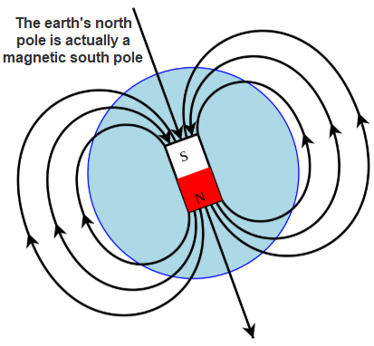It tells us in the question that the wavelength is between 1.3 m and 30 m.

$f=\frac{c}{λ}$ so the smallest frequency will occur with the largest wavelength which in this case is 30 m.

*=*

*f* = 1 × 107 Hz

* 1. **Draw a diagram of the magnetic field around the Earth.**See diagram
  2. **Explain how information is transmitted using optical fibres.**

1. Light enters one end of the fibre and strikes the boundary between the two materials *at an angle greater than the critical angle,* resulting in total internal reflection at the interface.
2. This reflected light now strikes the interface on the opposite wall and gets totally reflected again.
3. This process continues all along the glass pipe until the light emerges at the far end.  
   1. **Calculate the position of the image of a person standing 75 cm from the Leviathan mirror.**

$\frac{1}{f}=\frac{1}{u}+\frac{1}{v}$ $\frac{1}{16}=\frac{1}{0.75}+\frac{1}{v}$ $\frac{1}{16}-\frac{1}{0.75}=\frac{1}{v}$ $-\frac{61}{48}=\frac{1}{v}$

*v* = 79 cm behind the mirror

* 1. **Where, with respect to the concave mirror, will an image of the moon be formed?**

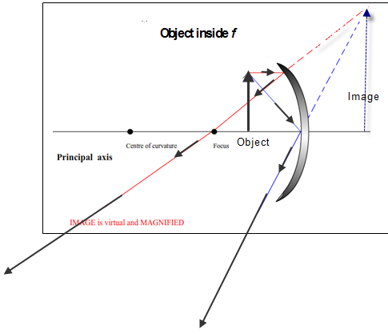Justify your answer.  
At the focal point, because the incoming rays are parallel.

* 1. **Draw a ray diagram to show the formation of an upright, magnified image in a concave mirror.**

See diagram

* 1. **Calculate the velocity of the Hubble telescope as it orbits the Earth.**

$$v=\frac{distance }{time}$$

*To calculate distance*

The telescope travels in a circular path at a height of 570 km above the ground.

Remember that the radius of the earth is 6400 km.

So the radius of this circle = (6400 + 470) km = 6870 km = 6.87 × 106 m

So the distance travelled in one orbit corresponds to the circumference of this circle = 2πr

= 2π(6.87 × 106)

*To calculate time*

The telescope does 15.1 orbits per day. So the time for one orbit is 24 divided by 15.1

= 1.589 hours = 1.589 × 60 × 60 = 5720.4 seconds

$v=\frac{distance }{time}= \frac{2π(6.87 × {10}^{6})}{5720.4}$ = 7650 m s-1

* 1. **Name one optical phenomenon . . .  
     How does the location of the Hubble telescope eliminate this problem?**

Refraction

The Hubble telescope is above the atmosphere

**2017 Question 12 (c)**

1. **Draw a ray diagram to illustrate how Rembrandt used a concave mirror in this way.**

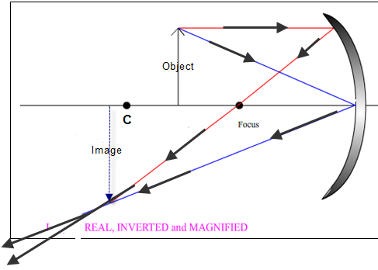

1. **Calculate the distance from the sheet to the mirror.**

$M=\frac{image height}{object height}= \frac{v}{u}$ $= \frac{1}{2}$*u* = 2*v*

$\frac{1}{f}=\frac{1}{u}+\frac{1}{v}$ $\frac{1}{60}=\frac{1}{2v}+\frac{1}{v}$ $\frac{1}{60}=\frac{3}{2v}$*v* = 90 cm

1. **Calculate the distance from the object to the mirror.**

*u* = 2*v u* = 180 cm

1. **Explain why this image was not of use to Rembrandt.**  
   The image formed would be a virtual image which could not be formed on a sheet

**2015 Question 12 (b)**

1. 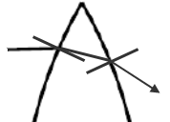**Copy the diagram on the right into your answer book and complete the path of the light ray through the section of the lens.**

*At the first interface the light ray is travelling from a medium of low refractive index to a medium of higher refractive index and so bends towards the normal.*

*The opposite happens at the second interface (light ray bends away from the normal).  
The opposite happens at the second interface (light ray bends away from the normal).*

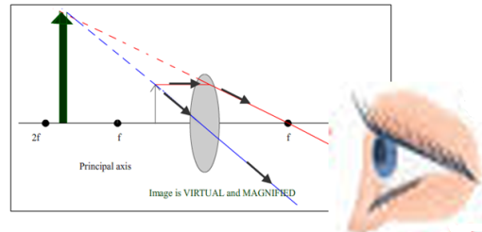

1. **Draw a ray diagram to show the formation of a virtual image in a converging lens.**

See diagram

1. **Calculate the power of the combination.**

Ptotal = P1 + P2

P1 = = 5 m-1 P2 = = -12.5 m-1 {the second lens is diverging and so is negative}

Ptotal = 5 – 12.5 m-1Ptotal = –7.5 m–1

1. **What eye defect can be corrected using converging lenses?**  
   Long-sightedness

**2014 Question 12 (b)**

1. **What is reflection?**   
   Reflection is the bouncing of light off a surface.
2. 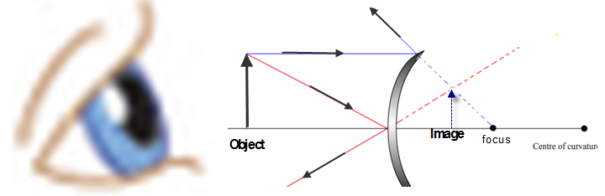**Draw a ray diagram to show the formation of an image in a convex mirror.**
3. **Find the position of the image.**

*{Note that the focus is half-way between the centre of curvature and the mirror. The diameter of the decoration is 20 cm. Therefore the radius is 10 cm. Therefore the centre of curvature is 10 cm from the mirror. Therefore f = 5 cm.}*

*Note also that we make $\frac{1}{f}$ negative to represent the fact that we are dealing with a convex mirror.*

$-\frac{1}{f}=\frac{1}{u}+\frac{1}{v}$ $-\frac{1}{5}=\frac{1}{30}+\frac{1}{v}$ $-\frac{1}{5}-\frac{1}{30}=\frac{1}{v}$ $-\frac{7}{30}=\frac{1}{v}$*v* = $-\frac{30}{7}$ = - 4.3 cm

*{the negative sign indicates that the image is virtual and is formed behind the mirror}*

1. **Concave mirrors, rather than convex mirrors, are used by dentists to examine teeth. Explain why.**  
   To give a magnified image

**2012 Question 12 (b)**

1. **If the refractive index of the glass is 1.5, calculate the value of *θ*.***This is one of the nastiest questions I have seen on any paper.**First, recognise that that θ does not represent the angle of incidence; you need to subtract the angle of incidence from 90 to get θ.**Secondly, the angle of refraction r is 600 not 300.**Finally, anytime you are told that the refractive index of a material is 1.5, what is implied is that light is going from air into this medium (go back and learn the full definition of refractive index to see why).  
   In this case the light is going from the medium (glass) to air, therefore the refractive index is $\frac{1}{1.5}$*

$\frac{\sin{i}}{\sin{60}}$**= $\frac{1}{1.5}$** Therefore *i* = 35.260 Therefore *θ* = 54.740 ***{****Told you it was nasty}*

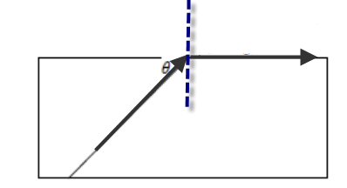

1. **What would be the value of the angle *θ* so that the ray of light emerges parallel to the side of the glass block?**

the angle that would result in the ray of light emerging parallel to the side of the glass block is called *the critical angle*

c = 41.820 *θ* = 48.20

*{Here we don’t have to worry about the direction of light; the formula for the critical angle assumes that light is going from the medium to air.}*

1. **Calculate the speed of light as it passes through the glass.**

cg = 2 ×108 m s-1

**2011 Question 12 (b)**

1. **State the laws of refraction of light.**

The incident ray, refracted ray and normal all lie in same plane

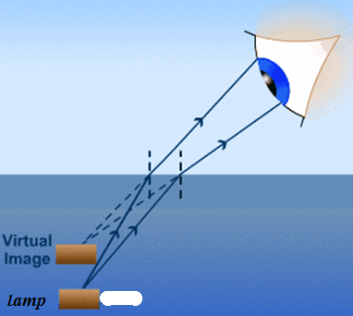sin i/sin r is a constant

1. **Draw a ray diagram to show where the lamp appears to be, as seen by an observer standing at the edge of the pool.**

See diagram

1. **Explain why the area of water surrounding the disc of light appears dark.**

The angle of a ray of light coming from the lamp to a point on the surface *outside* the disc will be greater than the critical angle so gets totally internally reflected.

1. 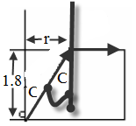**Calculate the area of the illuminated disc of water.**

The formula for area of a disc is πr2, so we need a value for *r*.

First we can calculate a value for the critical angle *C* using

$η=\frac{1}{\sin{i_{c}}}$ $\sin{i_{c}}=\frac{1}{η}$ ic = 48.760

From the wonderful diagram on the right, we can see that if we know C and the depth of the pool (which is 1.8 m), then we can use trigonometry to work out *r*.

$\tan{C= \frac{r}{1.8}}$*r* = 1.8 tan C *r* = 2.053 m Area = πr2 = π(2.053 )2

Area = 13.24 m2

**2009 Question 12** **(c)**

1. **Explain, with the aid of a labelled diagram, how a ray of light is guided along a fibre.**

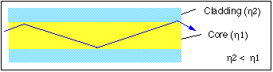

1. An optical fibre consists of a glass pipe coated with a second material of lower refractive index.
2. Light enters one end of the fibre and strikes the boundary between the two materials *at an angle greater than the critical angle,* resulting in total internal reflection at the interface.
3. This reflected light now strikes the interface on the opposite wall and gets totally reflected again.
4. This process continues all along the glass pipe until the light emerges at the far end.
5. **Why is each fibre coated with glass of lower refractive index?**

Because total internal reflection can only occur for rays travelling from a medium of higher to lower refractive index.

1. **What is the speed of the light as it passes through the fibre?**

⇒ = = 1.94 × 108 m s-1

1. **What is the power being transmitted by the light after it has travelled 8 km through the fibre?**

After 2 km power has dropped to 5 W; after 4 km power has dropped to 2.5 W; after 6 km power has dropped to 1.25 W; after 8 km power has dropped to 0.625 W.

Answer: 0.625 W

**2008 Question 9**

1. **What is meant by refraction of light?**

Refraction is the bending of light as it passes from one medium to another (of different refractive index).

1. **State Snell’s law of refraction.**

The ratio of the sin of the angle of incidence to the sin of the angle of refraction is a constant.

1. **Calculate how near an object can be placed in front of the eye and still be in focus.**

The maximum power of the eye system = 64 m–1. This allows us to calculate *f*.

$P=\frac{1}{f}$ $f=\frac{1}{p}$ = $\frac{1}{64}$ = 0.0156 m *f* = 1.56 cm

The retina is 2.0 cm from the lens system. The image is formed on the retina and the distance from lens system to retina corresponds to the image distance. So *v* = 2.0 cm

$\frac{1}{f}=\frac{1}{u}+\frac{1}{v}$ $\frac{1}{1.56}=\frac{1}{u}+\frac{1}{2}$ $\frac{1}{0.14}=\frac{1}{u}$*u* = 7.14 cm

1. **Calculate the maximum power of the internal lens.**

Ptotal = P1 + P2 PTotal = Pfixed lens + Pvariable lens  64 = 38 + P2  P2 = 26 m-1

1. **Calculate the refractive index of the cornea.**

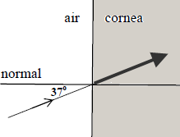 = 1.33

1. **Draw a diagram to show the path of a ray of light as it passes from water of refractive index 1.33 into the cornea.**

Both media have the same refractive index so the light ray doesn’t bend.

1. **When underwater why does the cornea not act as a lens?**

Because the cornea has the same refractive index as water, therefore light doesn’t bend as it passes from water into the cornea.

1. **What is the maximum power of the eye when underwater?**

The maximum power of the eye is 64 m–1, but this includes the focusing power of the cornea (which is 38 m-1). But the cornea no longer acts as a lens when underwater, so all that’s left is the internal lens, which as we have calculated above has a maximum power of 26 m–1.

1. **Why do objects appear blurred when underwater?**

Because the internal lens by itself is not powerful enough to focus light onto the retina.

1. **Explain how wearing goggles allows objects to be seen clearly.**

Because light which hits the cornea is now entering the cornea *from air* and therefore *will* refract so the cornea will once again act as a lens.

**2006 Question 7**

1. **What is meant by the refraction of light?**

Refraction is the bending of light as it passes from one medium to another.

1. **Draw a ray diagram to show how an erect image is formed by a magnifying glass.**

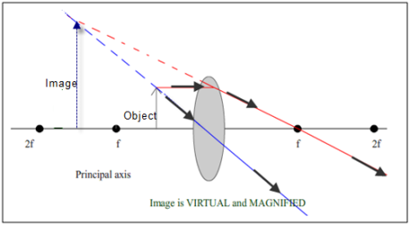See diagram

1. **Explain why.**

The image is always diminished.

1. **Determine the two positions that an object can be placed to produce an image that is four times the size of the object?**

$M=\frac{v}{u}$ The image is 4 times the size of the object  M =4  *v*=4*u*

       4*u* = 40   
 *u* =10 cm

*{The other way an image could be formed is if the object is inside the focus.*

*This would result in a* ***virtual*** *image, and we represent this mathematically by making v* ***negative****.}*

       4*u* = 24   
 *u* =6 cm

*{Note that our value for u is less than the value for f, implying that the object is inside the focus, as we would expect.}*

1. **Calculate the focal length of the lens required to correct this defect.**

PTotal = P1 + P2  PCorrected lens = Pdefective lens + Pcorrective lens

60 = 64 + P2  P2 = -4 m-1

*f* = 0.25 m

1. **What type of lens is used?**

Diverging / concave lens

1. **Name the defect.**

Short sight / myopia

**2004 Question 12 (b)**

1. **Give two reasons why the telecommunications industry uses optical fibres instead of copper conductors to transmit signals.**

Less interference, cheaper raw material, occupy less space, more information carried in the same space, flexible for inaccessible places, do not corrode, etc



1. **Explain how a signal is transmitted along an optical fibre.**

Inner core has a greater refractive index than the outer core.

A light ray is introduced at one end of the fibre and strikes the interface at an angle greater than the critical angle so total internal reflection occurs.

This continues all along the fibre.

1. **An optical fibre has an outer less dense layer of glass. What is the role of this layer of glass?**

Total internal reflection will only occur if the outer material has a greater refractive index.

It also prevents damage to the surface of the core.

1. **An optical fibre is manufactured using glass of refractive index of 1.5.**

**Calculate the speed of light travelling through the optical fibre.**

$refractive index=\frac{speed of light in air}{speed of light in medium}$

$c_{glass}=\frac{C_{medium}}{refractive index}$ $c_{glass}=\frac{3 × {10}^{8}}{1.5}$ Cglass = 2.0 × 108 (m s-1)

**2002 Question 12 (b)**

1. **State the laws of refraction of light.**

The incident ray, the normal and the refracted ray all lie on the same plane.

The ratio of the sin of the angle of incidence to the sin of the angle of refraction is a constant.

1. 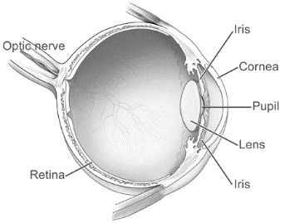**Draw a labelled diagram showing the optical structure of the eye.**

See diagram.

1. **How does the eye bring objects at different distances into focus?**

The shape of the lens can change (by contracting and relaxing the cilary muscles). This causes the focal length (and the power) of the lens to change; this needs to adjust on the basis of whether the person is looking at something up close or something far away.

1. **Calculate the power of the contact lens required to correct the person’s short-sightedness.**

PTotal = P1 + P2 P*corrected eye* = P*defective eye* + P*corrective lens*

60 = 65+ P2

P2 = - 5 m *{the negative sign indicates that it is a concave or diverging lens}*

1. **Calculate the focal length of the contact lens required to correct the person’s short-sightedness.**

⇒ f = 0.2 m

*{notice that the negative sign has no mathematical significance and so can be ignored here}*